* **Story Board for MY PEDO FITNESS (BETA VERSION)**

|  |  |  |  |  |  |  |
| --- | --- | --- | --- | --- | --- | --- |
| **Issue Type** | **Priority level** | **KEY** | **Description** | **Due Date** | **Assignee** | **Status of Task** |
| Task 1 | MAJOR | MYPEDO-5 | Gather the application requirements like sensor requirements and the flow of functionality by watching provided videos multiple times and understanding projects related to Pedo App. | June 30th, 2020 | Jasmeen | Completed |
| Task 2 | MAJOR | MYPEDO -6 | UPDATES the requirements in Android Studio for proper functioning | June 30th, 2020 | Jasmeen | Completed |
| Task 3 | MAJOR | MYPEDO -7 | Start the project working on the code for making Step Counter | June 30tth ,2020 | Jasmeen | Completed and resolved issues |
| Task 4 | MAJOR | MYPEDO -8 | Removing the ERRORS in the coding and adding required libraries | June 30th, 2020 | Jasmeen |  |
| Task 5 | MAJOR | MYPEDO -9 | Check the Functionality of Step Counter in Android Phone | June 30th, 2020 | Jorawar | Checked |
| Task 6 | MAJOR | MYPEDO -10 | Working on the unfunctional code for Step Detector (continue in Delta Version) | June 30th, 2020 | Jorawar | Resolved |
| Task 7 | MAJOR | MYPEDO -11 | Making the .Apk of the My PEDO APP till now. | June 30th, 2020 | Jasmeen | Completed |

**Result of Beta Version:**

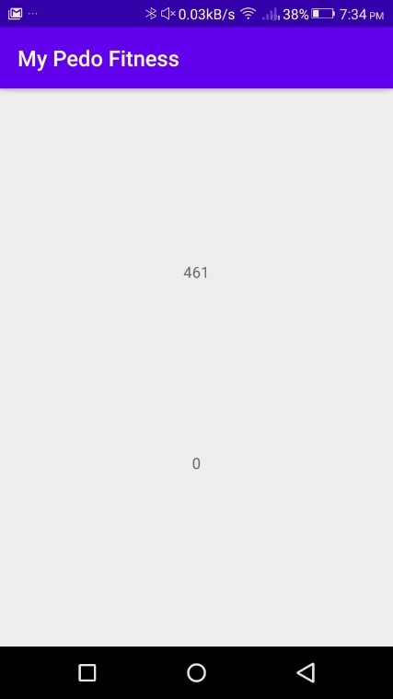

* **Story Board for MY PEDO**

**FITNESS (DELTA VERSION)**

|  |  |  |  |  |  |  |
| --- | --- | --- | --- | --- | --- | --- |
| **Issue Type** | **Priority level** | **KEY** | **Description** | **Due Date** | **Assignee** | **Status of Task** |
| Task 1 | MAJOR | MYPEDO-12 | Revise the work done in BETA VERSION and if needed any changes make it before moving further | July 7th, 2020 | Jorawar | Completed |
| Task 2 | MAJOR | MYPEDO -13 | Working on the functionality of Step Detector (started in BETA VERSION) | July 7th, 2020 | Jorawar | Completed |
| Task 3 | MAJOR | MYPEDO -14 | Remove Errors and check other requirements for App if any. | July 7th, 2020 | Sidharth | Resolved |
| Task 4 | MAJOR | MYPEDO -15 | Checking the functionality for both Step Counter and Step Detector in Android Phone | July 7th, 2020 | Sidharth | Checked |
| Task 5 | MAJOR | MYPEDO -16 | If workflow good, will Start working on Graphics and design. | July 7th, 2020 | Sidharth | Completed |

**Result of Delta version: (with dummy layout)**

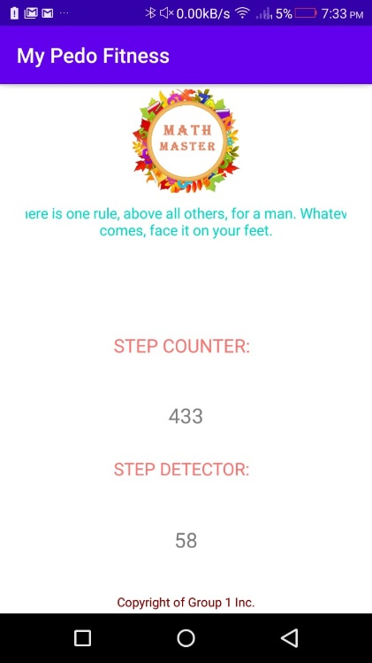

* **Story Board for MY PEDO FITNESS (GOLD VERSION)**

|  |  |  |  |  |  |  |
| --- | --- | --- | --- | --- | --- | --- |
| **Issue Type** | **Priority level** | **KEY** | **Description** | **Due Date** | **Assignee** | **Status of Task** |
| Task 1 | MAJOR | MYPEDO-17 | Revise the work done in DELTA VERSION and if needed any changes make it before moving further | July 8th, 2020 | Jasmeen | Completed |
| Task 2 | MAJOR | MYPEDO -18 | Will start gathering the graphics we made in DELTA VERSION and implement in the Application | July 8th, 2020 | Jasmeen | Completed |
| Task 3 | MAJOR | MYPEDO -19 | Work on the interface and the looks of Application. | July 8th, 2020 | Jasmeen | Completed |
| Task 4 | MAJOR | MYPEDO -20 | Checking for errors if any | July 8th, 2020 | Jorawar | Checked and Resolved |
| Task 5 | MAJOR | MYPEDO -21 | Club everything to make it a single functional application | July 8th, 2020 | Sidharth | Completed |
| Task 6 | MAJOR | MYPEDO-22 | Check the final developed application in Android Phone | July 8th, 2020 | Sidharth | Completed |

**Result of Gold Version:**

